COS10029 – Fundamentals of Programming
Name: Sovithyea Prach
Student ID: 105270743
Task 3.1
Code:
#include <iostream>
using namespace std;

double find_velocity(double u, double a, double t)
{
double v;
v = u + a * t;

return v;
}

int main()
{
double initial_velocity, time, acceleration, velocity;

initial_velocity=10;
time=180;
acceleration=9.08;
velocity=find_velocity(initial_velocity, acceleration,time);
cout << "Velocity 1: " <<velocity<< endl;

initial_velocity=10.5;
time=10.5;
acceleration=12.5;
velocity=find_velocity(initial_velocity, acceleration,time);
cout << "Velocity 2: " <<velocity<<endl;

cout << "Enter the value of the initial velocity: ";
cin >> initial_velocity;
cout << "Enter the value of the acceleration: ";
cin >> acceleration;
cout << "Enter the value of time: ";
cin >> time;
velocity=find_velocity(initial_velocity, acceleration,time);
cout << "Velocity 3: " <<velocity<<endl;

return 0;
}

Output Screen:
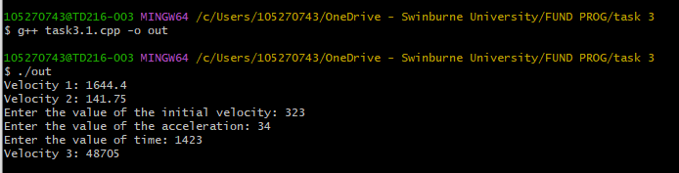

Task 3.2
Code:
//drawing a star
#include "splashkit.h"

void draw_star(color clr, double x, double y, int width, int height)
{
double x2=x+width;
double y2=y+height;
double left_x=x-width;
double mid_x=x+width/2;
double mid_y=y+height/2;
double bottom_y=y2+height;
double top_y=y-height;
double right_x=x2+width;

fill_rectangle(clr, x, y, width, height);
fill_triangle(clr, x, y ,x2, y, mid_x, top_y);
fill_triangle(clr, x2,y, x2, y2, right_x, mid_y);
fill_triangle(clr, x2, y2, mid_x, bottom_y, x, y2);
fill_triangle(clr, x, y2, left_x, mid_y, x, y);
}

int main()
{
open_window("Star", 800,600);
clear_screen(COLOR_WHITE);

draw_star(COLOR_GREEN, 100, 100, 100, 100);
draw_star(COLOR_RED, 600, 100,100,100);
draw_star(COLOR_BLUE, 100, 400, 100, 100);
draw_star(COLOR_ORANGE, 600, 400, 100, 100);
draw_star(COLOR_PURPLE, 350, 250, 100, 100);

refresh_screen(60);
delay(10000);

return 0;
}

Output Screen:
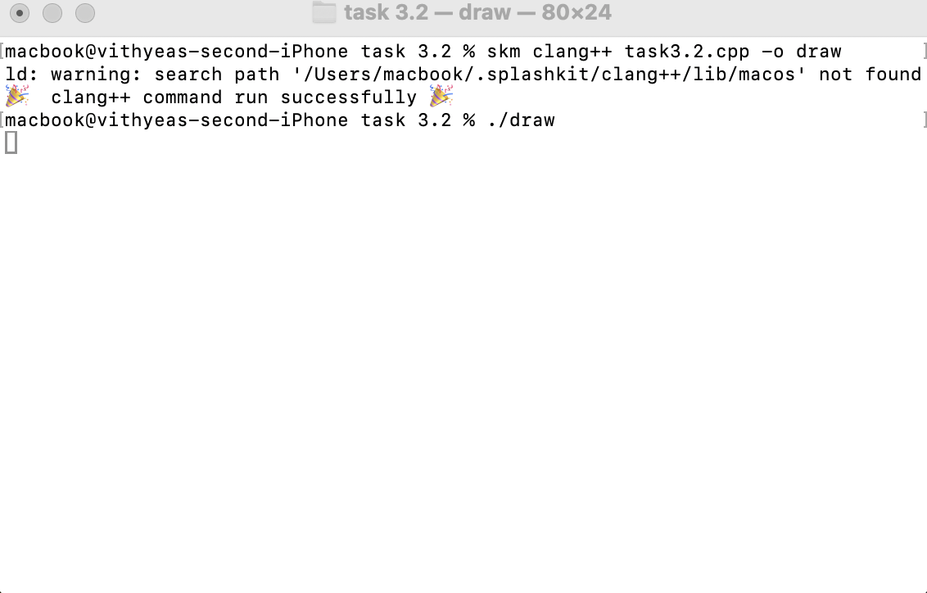

Star Drawing:
